Nutritional Therapy and Wellbeing Questionnaire

Title___________ First Name______________________ Last Name__________________________________ Date of Birth________________________
Address________________________________________________________________________________________________________________________________
Post Code____________________ Email_____________________________________________ Phone numbers___________________________________
Please circle appropriate answers below.
Employment Status:
Full time Part time Self-employed if employed please give occupation_________________________________
Homemaker Student Retired Unemployed Disabled Not specified.
Family Status:
Living with Parents Single Married Separated Divorced Widowed Partnered
Any Children_________ Ages_______________
Health Profile:
What is your main reason for seeking nutritional advice?________________________________________________________________________
What outcome are you hoping to achieve?_________________________________________________________________________________________
Are your symptoms affecting any activities in your every day life? If yes please specify.______________________________________
_____________________________________________________________________________________________________
Please list any health problems that may currently be affecting you, or that you would like to focus on.
Health Problem (e.g Diabetes) | Management so far (e.g. GP, operation, exercise, medication, painkillers etc.) | Onset (date) | Duration

Have you had any recent health tests? Please specify or attach, if appropriate__________________________________________________
__________________________________________________________________________________________________________________________________________

Have you had any other major surgery, biopsies, diagnosed medical conditions, significant periods of ill health or do you
Suffer from any chronic or niggling health problems? (please give details e.g high blood pressure, frequent colds etc.)_____
___________________________________________________________________________________________________________________________________________
___________________________________________________________________________________________________________________________________________
Do you suspect your symptoms relate to a particular event or time in your life?_________________________________________________
Medication and Remedies
Please list anything you take regularly including GP prescribed medication, self prescribed medication, herbal remedies
or nutritional supplements.
Remedy | Dose | Condition being treated | Frequency and Duration
Antibiotic history: please state when and why you last took antibiotics plus any previous times you can remember:

Your vital statistics
_________________ What is your normal blood pressure?
_________________ your resting pulse rate?
_________________ your current weight?
_________________ your height?
_________________ your waist circumference? (if known)
_________________ your hip circumference? (if known)
_________________ your blood type?
_________________ Is your weight stable, increasing or decreasing?
_________________ Did you have the normal immunisations as a child?
Your family history
Do you have a family history of disease or allergies? (e.g. heart disease, diabetes, asthma , etc.) If so state disease, age at
onset and gender.
Grandparents: ________________________________________________________________________________________________________________________
Parents: _______________________________________________________________________________________________________________________________
Siblings: _______________________________________________________________________________________________________________________________
Children: ______________________________________________________________________________________________________________________________
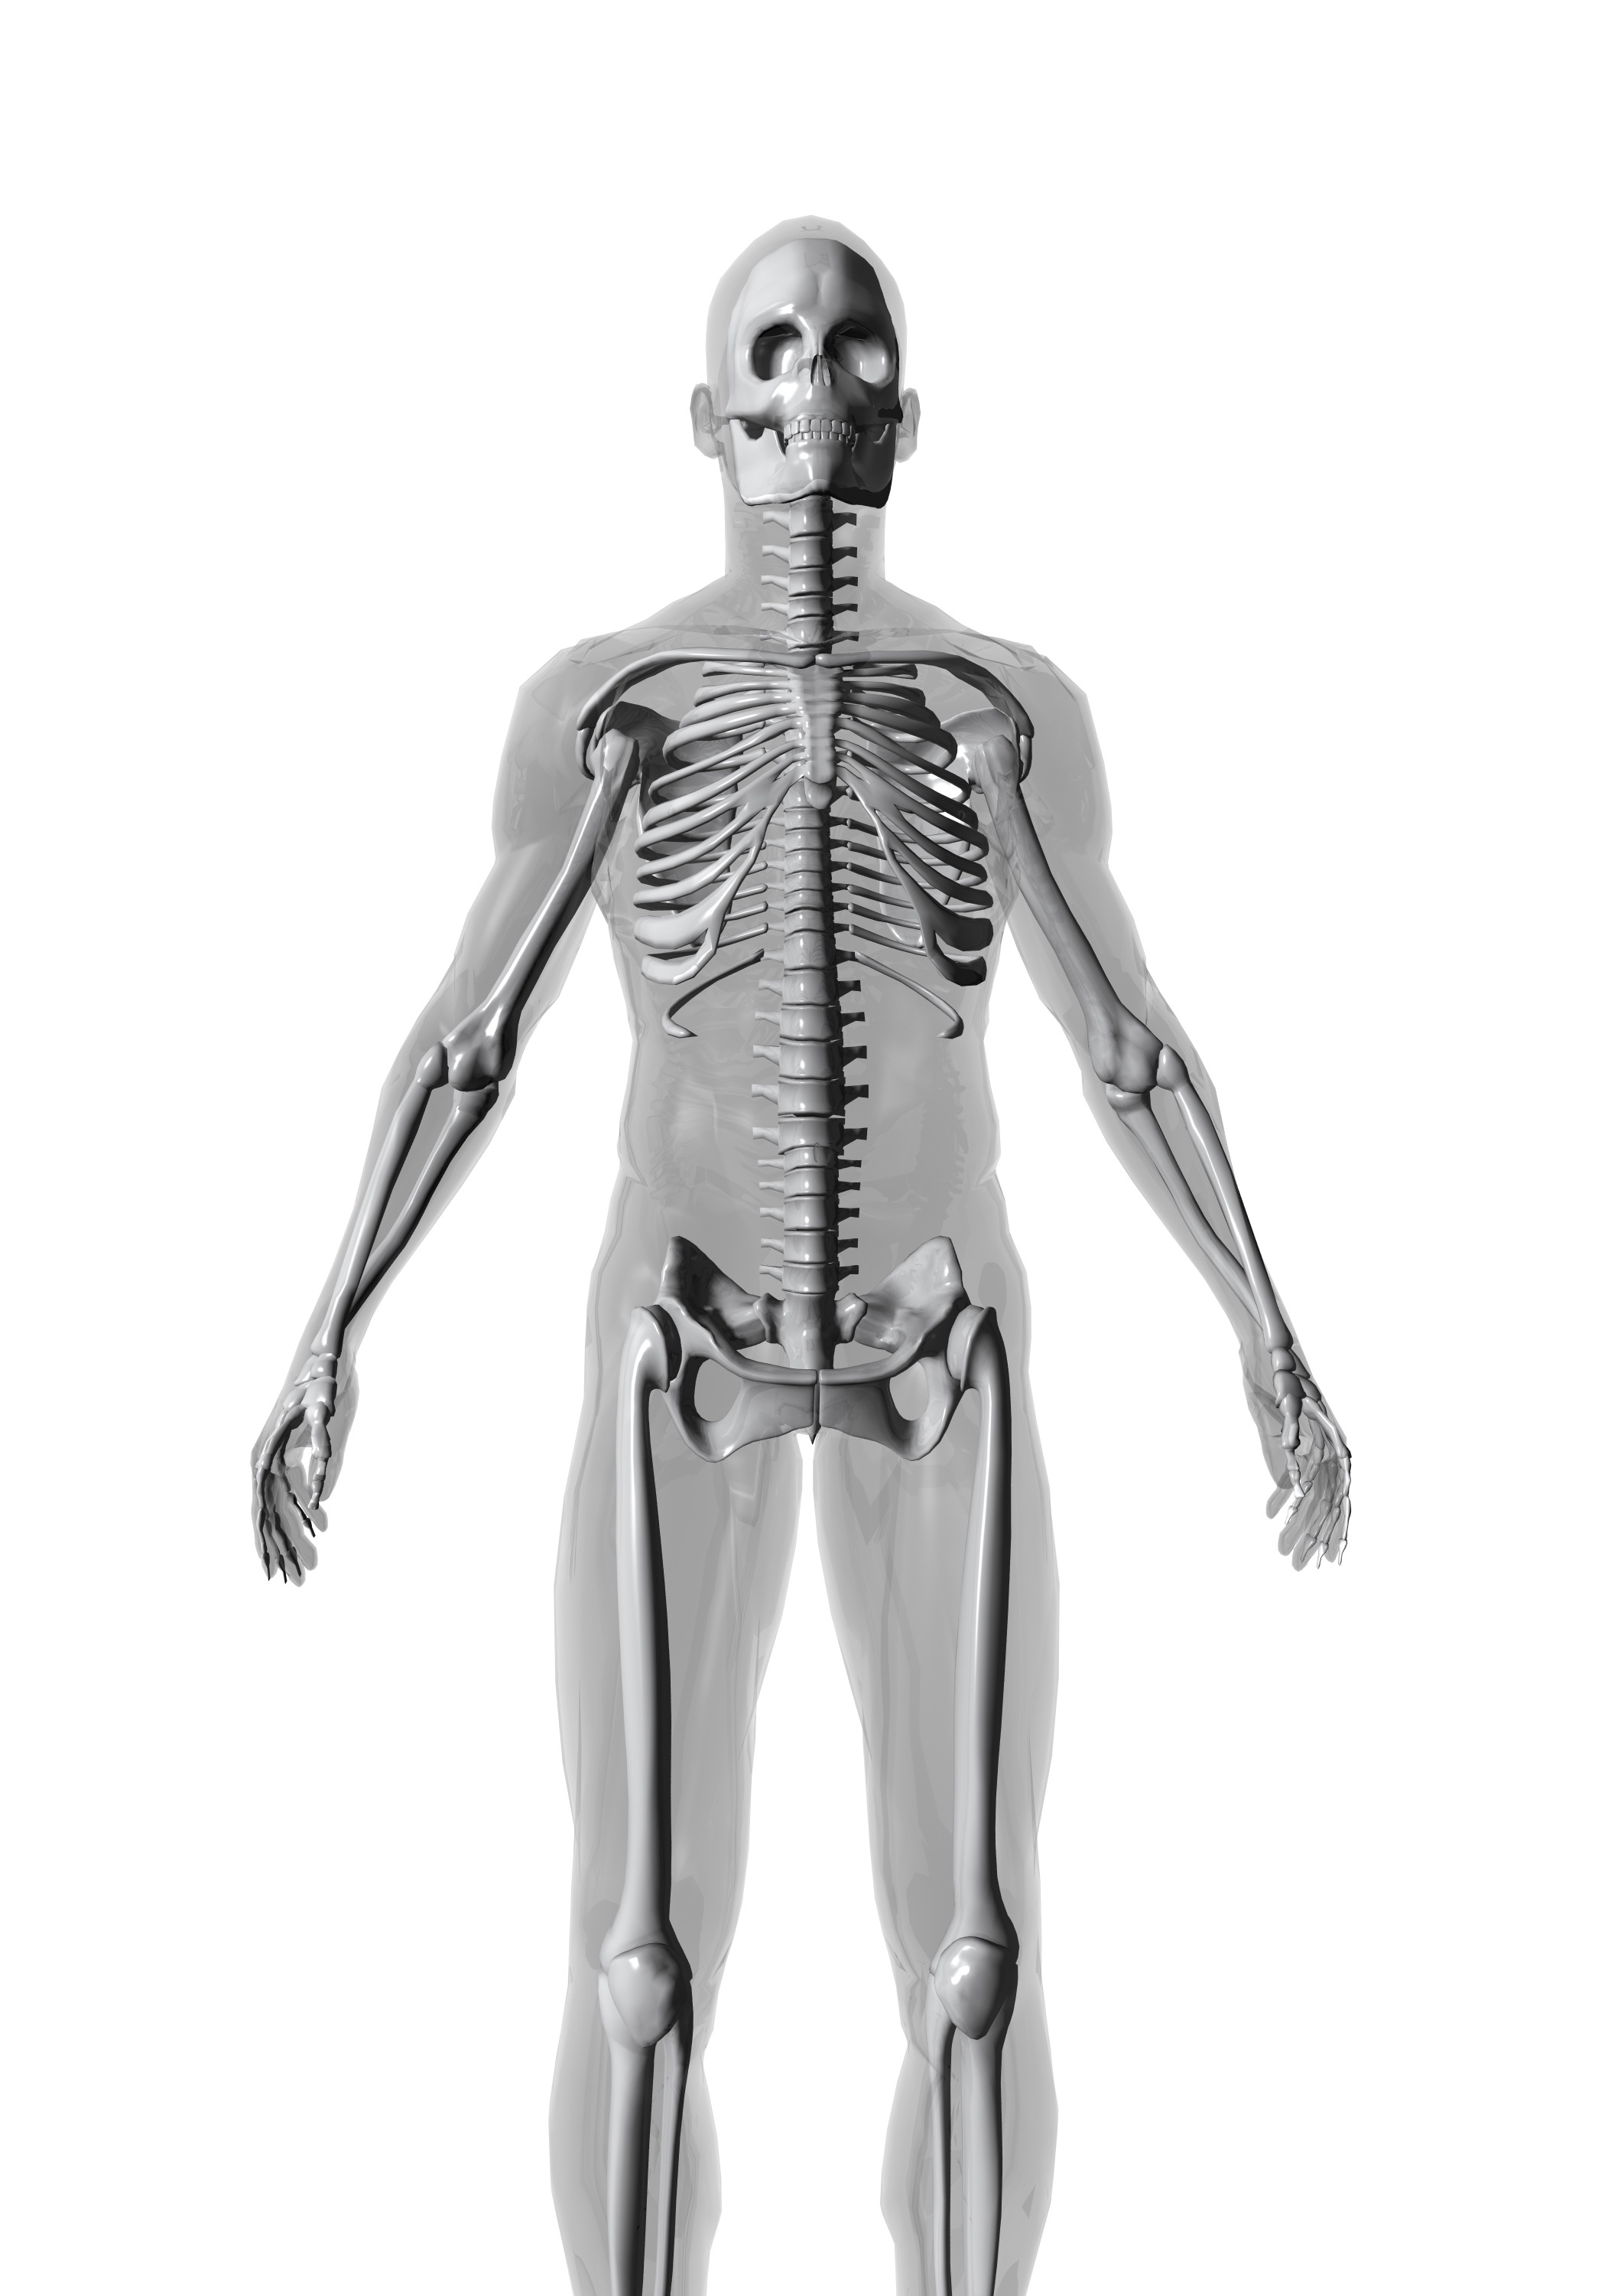
A DEEPER LOOK AT YOUR BODY Please underline or circle any conditions that you regularly experience

Head and Hair:
Headaches, migraine, stiff neck, fuzzy headed, dizziness, poor balance, pounding head, feeling of hangover
Oily hair, dry, poor condition, brittle, thinning, dandruff, increased facial or body hair, decreased body hair
Mind
Forgetful, difficulty learning new things, easily confused, difficulty concentrating, easily frustrated, indecisive, fogginess
Easily distracted, can’t switch off, dyslexia, dyspraxia, panic attacks, loss of interest in daily life, no motivation
Eyes
Burning, gritty, protruding, prone to infection, sticky, itchy, painful, poor night vision, dry, cataracts, sensitive to light, dark circles/bags, failing eyesight, yellowish
Ears
Blocked, sore, itchy, watery, overly waxy, creased earlobe
Nose
Stuffy, congested, runny, nose bleeds, prone to snoring, sinusitis, hay fever, post-nasal dip, rhinitis, sneezing, itchy, poor sense of smell, frequent colds
Mouth
Sore tongue, tooth decay, mouth ulcers, cold sores, bad breath, sore throats, poor sense of taste, dry mouth, bleeding gums, excess saliva, difficulty swallowing
Mood
Depressed, anxious, tense, angry, happy, balanced, optimistic, sad, pessimistic, tired, can’t be bothered, hyperactive,
Cheerful, agitated, easily upset, tearful, jittery, frightened, explosive, worried, overwhelmed, fluctuating, aggressive
Chest
Chest infections, asthma, bronchitis, diagnosed heart condition, chest pain, short of breath, persistent cough, wheezing
Muscles
Tender, sore, cramps, spasms, twitches, loss of tone, weak, stiff, frozen, restless legs, numbness
Skin
Dry, flaky, scaly, puffy, pale, brown patches, warts, oily, clammy, yellow, prematurely lined, change in moles, acne, boils, pimples, rosacea, eczema, dermatitis,
psoriasis, rashes, itching, stretch marks, cellulite, easy bruising, thread veins, ringworm, allergic reactions, excessive sweating
Hands and Nails
Dry, cracked, eczema, sore joints, puffy, cold, numbness, tingling, feel clumsy and uncoordinated, poor circulation, fragile nails, brittle, peeling, splitting,
ridged, white spots on more than 2 nails, horizontal white lines, pitted, thickened or horny
Joints
Painful, inflamed, swollen, stiff, rheumatic, arthritic, sore, difficulty bending, reduced mobility, slow movement
Gut
Bloated, tender, cramping, nausea, acid reflux, flatulence, belching, churning, pains, IBS, coeliac, hiatus hernia, polyps,
Diverticula, haemorrhoids, ulcers, constipation, diarrhoea, sensitive, sluggish
Genitals
Itchy, cystitis, thrush, ulcers, warts, herpes, prostatitis, impotence, painful intercourse, unexplained discharge, dryness, PID
Legs and feet
Restless legs, swollen, aching, athlete’s foot, fungal nails, burning feet, tender heels, gout, numb, tingling, cold feet, dry cracked heels

Your daily life
Do you enjoy daily life? _________________________________ How many people depend on your support? ___________________
Do you feel supported by people around you? _______ Do you feel guilty when you are relaxing? ______________________
Please circle or underline any of the following things that you may have experienced recently
Divorce Separation Become a new parent Bereavement Moved house Changed jobs
Are you under significant stress in any other way? _________________________________________________________________________________
Do you work long or irregular hours? ________________ Is your workload bigger than you can manage? ________________
Is your job active? ______________________________________ Do you exercise or have any active hobbies? ___________________
Do you sleep well? _____________________________________ What do you do for relaxation? __________________________________
Do you live close to an agricultural area? ____________ Do you smoke? If so, how many a day? _________________________
Do you heat, freeze or wrap food in plastics? _______ Are you exposed to chemicals through work or hobby? ______
Do you cook or wrap food in aluminium? ___________ Do you regularly take antacid (indigestion) medication? _____

Your digestion (Please circle or underline any of the following that you regularly experience)
Indigestion after food Indigestion between meals Nausea or vomiting Frequent stomach upsets or pain
Constipation Diarrhoea loose stools blood/mucus in the stools anal itching pain under the ribs.
How many bowel movements do you have in 24 hours? _____ Have you noticed any recent change in bowel habit? _________
Have you ever had a stomach upset after foreign travel? __________ Have you ever had thrush or cystitis? ____________________

Energy levels
On average how many hours of sleep do you get per night? _______________________________________________________________________
How would you rate your quality of sleep? (Please circle all that apply)
Poor Disturbed Restless Broken Not long enough Deep Restful Good Excellent
Do you find it difficult to get going in the morning? ___________ Is your energy less than you want it to be?__________________
Do you feel drowsy during the day? ____________________________ What time(s) of day is your energy lowest? ________________
Do you get dizzy or irritable if you don’t eat often? ___________ Do you find it difficult to concentrate? ______________________
Do you use caffeine, sugar or nicotine to keep going? ______________________________________________________________________________

Women only
Are you pregnant or breastfeeding? __________________ Have you had any problems with fertility? __________________
Are you still menstruating? ____________________________ Are your periods regular? ______________________________________
Are your periods particularly heavy/painful? _______ Do you suffer from PCOS, fibroids endometriosis? ___________
Are you happy with your sex drive? ________________ What contraception do you use? _______________________________

Men only
Have you had any problems with fertility? _______ Are you happy with your sex drive? ___________________________
Frequent or difficult urination? ____________________ Do you experience mood swings or depression? _____________

Eating Habits
What do you consider to be your daily eating pattern (please circle or underline all that apply).
Less than normal Normal Over eat Binge Excessive snacking Disordered eating
Which meals do you eat each day?
Breakfast Lunch Supper Mid- morning snack Mid-afternoon snack Evening snack
Which are your favourite foods? _____________________________________________________________________________________________________
Which foods do you like? _____________________________________________________________________________________________________________
Which foods do you crave? ___________________________________________________________________________________________________________
Which foods would you find hard to give up? _______________________________________________________________________________________
Do you cater for a special diet in the household? ___________ Who does the cooking in your household? _________________
Do you avoid any food for cultural/ethical reasons? _______ Have you recently changed your diet? ______________________
Do you suspect any foods don’t agree with you? ___________ Do you eat on the move/when stressed? ___________________
Do you ever have eating binges? _____________________________ What do you binge on? _______________________________________
Have you ever suffered from an eating disorder? __________ Do you chew your food properly? ___________________________
Do you drink alcohol, if yes how much per week? _________ What percentage, if any, of your food is organic? __________
How motivated are you in changing the way you eat? (please circle or underline the answer you most agree with)
I am ready and willing to try anything that might improve my condition and quality of life
I feel I can cope with a moderate amount of change.
I feel anxious about changing my diet, and hope it will fit into my lifestyle.
How willing are you to experiment and try new foods? (please circle or underline the answer you most agree with)
I am ready and willing to try anything that might improve my condition and quality of life
I feel I can cope with a moderate amount of change.
I feel anxious about changing my diet, and hope it will fit into my lifestyle

Health Care Providers
Is this your first visit to a Nutritional Therapist? _________ How did you find out about me? _____________________________
Please now provide name and contact details of your GP. __________________________________________________________________________
___________________________________________________________________________________________________________________________________________
Thank you for taking the time to complete this questionnaire.

Please now complete the separate 3 day food diary.

I have disclosed all the relevant information applicable to this questionnaire and my health status at this point in
time. I consent for the information provided to be used by my Nutritional Therapist and if necessary for her to liaise
further with appropriate health professionals.

Signed__________________________________________________________________ Date ____________________________________________________

ANY ADDITIONAL NOTES

